## Read and match

mosque

hospital

church

school

## Shade this

P4

P3

P2

P1

**Top class: package**



P

P

P

P

1 2 3 4



|  |  |
| --- | --- |
|  |  |
|  |  |

|  |  |
| --- | --- |
|  |  |
|  |  |

|  |  |
| --- | --- |
|  |  |
|  |  |

|  |  |
| --- | --- |
|  |  |
|  |  |

## Read and match things found in class

book table pencil chair bell



## Name these people at home

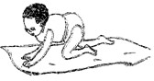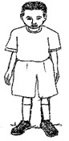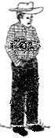

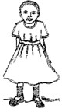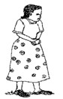(mother, sister, baby, brother, father)

## Read and draw

Rake panga

Axe broom

Pin basket

## Name the pictures

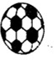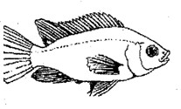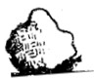

(fish, ball, moon, stone

## Write correctly



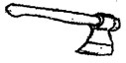

1. Make sentences

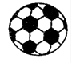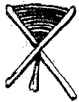

## Read and match a picture to a word

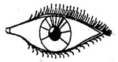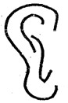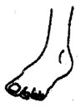

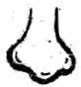

leg

ear

eye

mouth

nose

|  |  |  |  |
| --- | --- | --- | --- |
| ear |  | pot | eye |
| tree | girl |  | leg |
| nose |  | box | boy |
| book |  | hand | ball |

## Match the same and write

**10. Circle the body parts**

dress pant

short trousers

skirt vest

pant dress

trousers short

vest skirt

## Match and draw.

towel water

soap toothbrush

water comb

sponge towel

toothbrush toothpaste

comb sponge

toothpaste soap

## Count, read and match

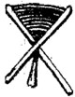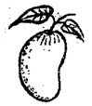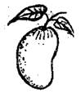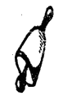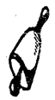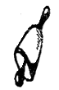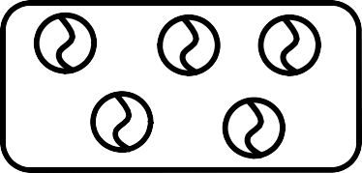

nineteen

five

fourteen

eight

three

eleven

## Shade well

1. **Write the next numbe**

**21**  **23, 24,**  **.**

11, 12, 14 15

17, , 19,

25, 26, , 28, 30

5, , , 8, , 10

, , 3, 4, .

## Circle the number for the given word

|  |  |  |  |  |
| --- | --- | --- | --- | --- |
| Seven | 1 | 7 | 17 | 6 |
| Fifteen | 5 | 11 | 15 | 8 |
| two | 17 | 2 | 3 | 9 |
| Thirty | 30 | 5 | 3 | 5 |
| Thirteen | 3 | 6 | 13 | 7 |
| Twenty | 1 | 2 | 3 | 20 |
| Five | 2 | 3 | 5 | 4 |
| Eight | 6 | 7 | 8 | 9 |
| One | 11 | 4 | 1 | 9 |
| Seventeen | 4 | 6 | 17 | 8 |

1. **Count and add**

2 + 1 = 3 1 + 1 =

1 + 1 = 3 + 0 =

3 + 0 = 2 + 2 =

2 + 2 = 4 + 1 =

## Match and write

20 25

21 24

22 20

23 21

24 22

25 23

=

**19.Take away**

=

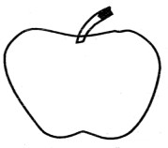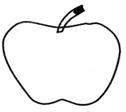

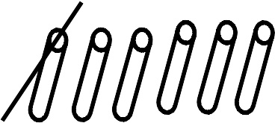=

=

## Write three words for the given sound

|  |  |  |  |
| --- | --- | --- | --- |
| **igh** |  |  |  |
| **ai** |  |  |  |
| **tion** |  |  |  |
| **ea** |  |  |  |
| **bl** |  |  |  |
| **ay** |  |  |  |
| **br** |  |  |  |

1. **Fill in the missing sound and read the word**

b k

d p

ment n

T cher

Moth

D ctor

Fa er

C p

Pr st

Ch rch

Br ther

D ck

1. Match animal and their young ones. dog baby

pig kid

lion calf

duck chicks

goat piglet

hen duckling

cow cub

mother puppy

**Writing**



# 15

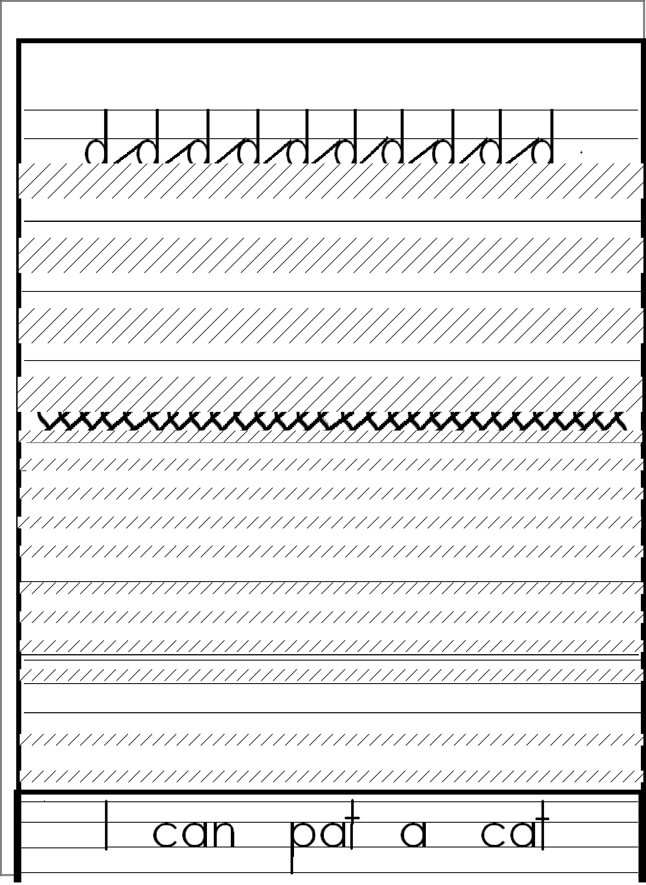

**2**

**. Write well**

**Read and write**

# 16

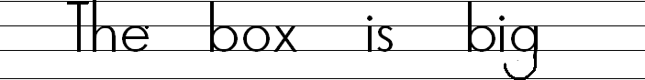

Read the story and answer the questions.

Once upon a time, there lived a man and a woman. They had two children, one was Rose and another was Tom.

Rose was so stubborn at home and Tom was a good and quiet boy

One day, when they were going to school Rose knocked her foot when she was running because she could not move properly on the way and what Tom did, he ran back home and called their mother to come and take Rose to the clinic.

## Questions

* 1. How many children are in the story?
  2. What was the name of the girl?
  3. What was the name of the boy?
  4. Who was the stubborn child?
  5. Who knocked the foot?

***end***